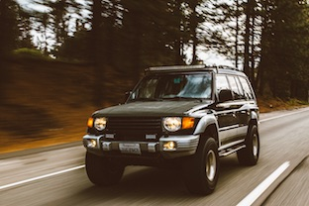

**Source is fictional**

URL

Author

Title

Date

https://www.favoritecars.com/photos/chang/12-34

Favorite Cars

Posted: 09/23/2017

Black Jeep

Photography by Gerald Chang